Contact Manager
Ideation Phase
Brainstorm & Idea Prioritization

Date | 07/03/2026
Team ID | NM2025TMID39961
Project Name | Contact Manager
Maximum Marks | 4 Marks

Brainstorm & Idea Prioritization
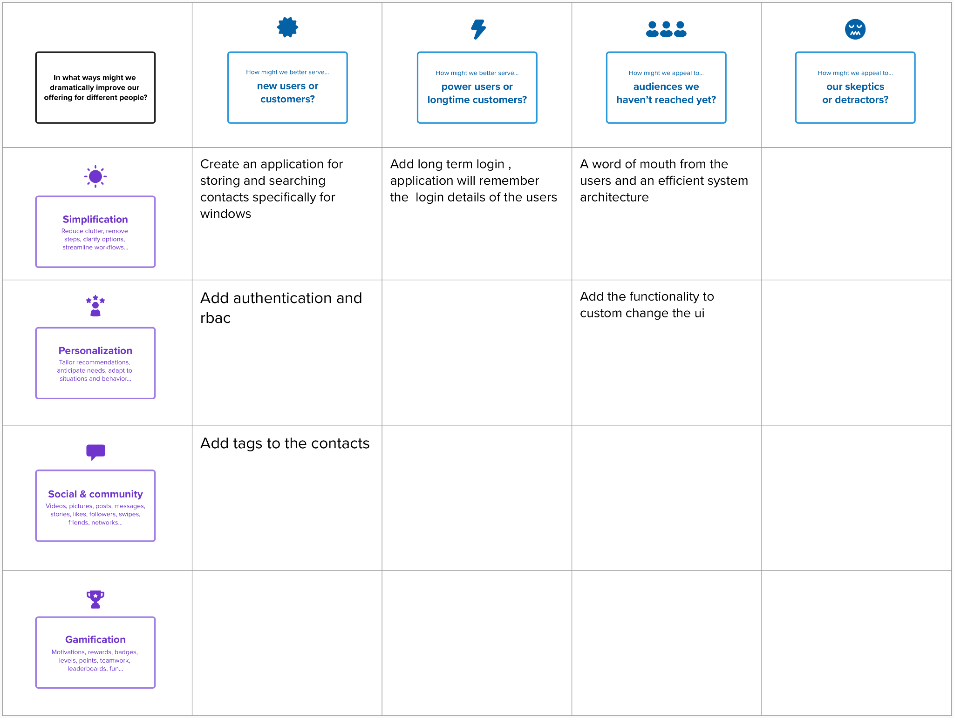

Ste 2 : Idea Prioritization
